Stage 7 – No doubt in my mind.
COURSE DESIGNER: Rocky Perillo
SCORING: Comstock 28 rounds.
TARGETS: 13 cardboard targets, 2 steel targets
SCORED HITS: 2 Best hits per carboard will be scored.

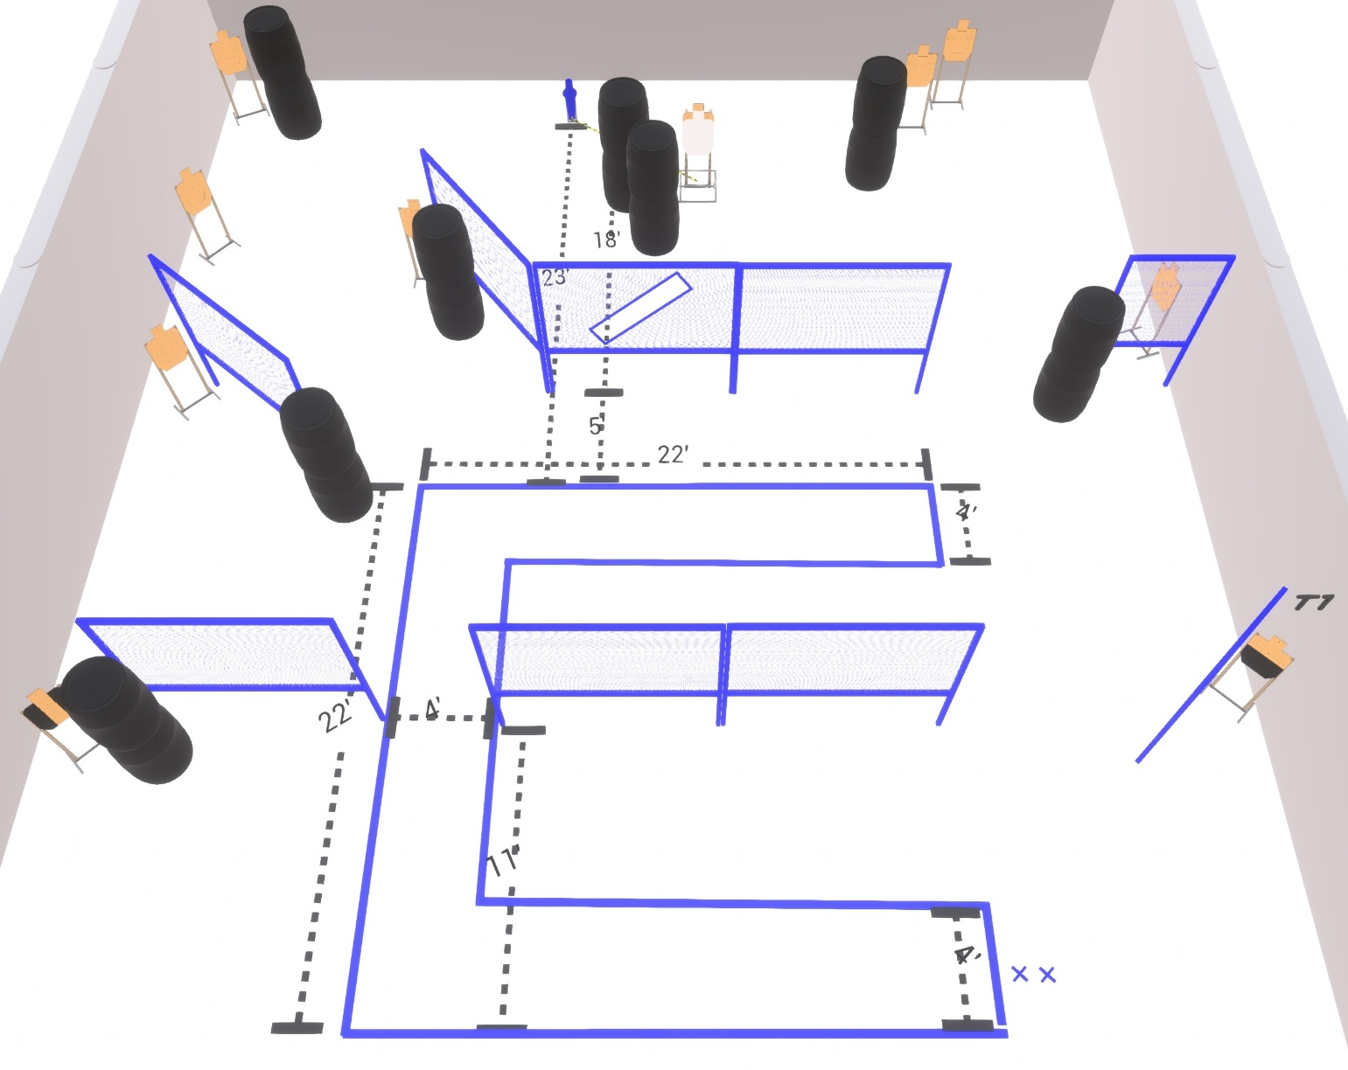

Written Stage Briefing:

Stage 7 – No doubt in my mind. - is a 22 round, 110 point, Comstock Course. There are 10 cardboard targets and 1 steel target
The best 2 hits per static cardboard target will be scored.
The best 3 hits on the Max Trap will be scored.

Starting with both feet on the Shooting Sports Innovations Xs.
Handgun is loaded and holstered, wrists below belt.
PCC is loaded held in both hands, stock on belt.

Popper activates Max Trap which is NOT visible at rest.

On the audible start signal, engage targets from within the shooting area.

USPSA / NROI Range Commands:
- Make Ready
- Are you ready?
- Standby
- If finished, unload and show clear
- If clear, hammer down and holster (Handgun)
If clear, hammer down and flag (PCC)
If clear, cylinder closed and holster (Revolver)
- Range is clear

Setup Notes:
12 Single Wall Stands
3 Double Wall Stands
6 Full Walls
2 Half Walls
9 Target stands / 18 target sticks
1 Max Trap + activation cables
2 Mover target sticks
1 Small Activator popper
16+ Barrels

